Emotional Wellbeing whilst in self-isolation (children, young people and adults)

Top tips for staying emotionally healthy during self-isolation:

5 ways of wellness:
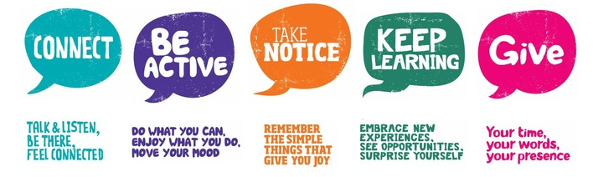

  - Stick to a active daily routine (e.g. creating your own daily programme including three meals a day, activity time slots, self-care opportunities and bedtime routine)

  - Do light activity - stretch and home workouts (e.g. yoga, dance, spring cleaning the house)

  - Keep up hobbies that keep you moving (e.g. baking, reading, writing, making music, gardening etc)

  - Engage in creative activities (e.g. art, scrap book making, junk modelling, restoring furniture, create music, redecorating)

  - Keep connected to others (e.g. phones, email, skype, websites, helplines & online counselling)

  - Keep an active mind (e.g. learning a new skill, research, brain training games, home learning using such free websites)

  - Try Meditation and relaxation (e.g. Apps and free YouTube videos such as headspace)

  - Hot desk at home with planned short brain breaks

  - Plan meals in advance

  - Do things you enjoy doing (e.g. watch a boxset, paint your nails, listen to podcasts, reading etc)

  - Keeping hydrated

  - Self-care opportunities (Self-care is any activity that we do deliberately in order to take care of our mental, emotional, and physical health. Although it's a simple concept in theory, it's something we very often overlook. Good self-care is key to improved mood and reduced anxiety)

